ER DIAGRAM

A Microgoal ER Diagram (Entity–Relationship Diagram) is used to represent how microgoals, users, tasks, and progress are related in a system (often used in productivity or habit-tracking apps).
1. Main Entities
Typical entities in a Microgoal system:
- User
- Microgoal
- Task
- Progress
- Category
2. ER Diagram Structure
User
-----
user_id (PK)
name
email
password
1
User ----------- creates ----------- N Microgoal
Microgoal
---------
microgoal_id (PK)
title
description
deadline
category_id (FK)
user_id (FK)
1
Microgoal -------- contains -------- N Task
Task
----
task_id (PK)
task_name
status
due_date
microgoal_id (FK)
1
Task -------- tracked_by -------- N Progress
Progress
--------
progress_id (PK)
date
completion_percentage
task_id (FK)
Category
--------
category_id (PK)
category_name
1
Category -------- groups -------- N Microgoal
3. Simple ER Diagram (Visual)
[User] 1 ─────── N [Microgoal] 1 ─────── N [Task] 1 ─────── N [Progress]
│
│
N
[Category]
4. Relationship Explanation
- User → Microgoal : One user can create many microgoals.
- Microgoal → Task : Each microgoal contains multiple small tasks.
- Task → Progress : Task completion can be tracked over time.
- Category → Microgoal : Microgoals can be grouped by category.
5. Example
User: Arun
Microgoal: Learn Python Basics in 7 Days
Tasks:
- Install Python
- Learn variables
- Practice loops
Here is an example of an ER (Entity-Relationship) diagram image that shows how entities, attributes, and relationships are structured in a database.

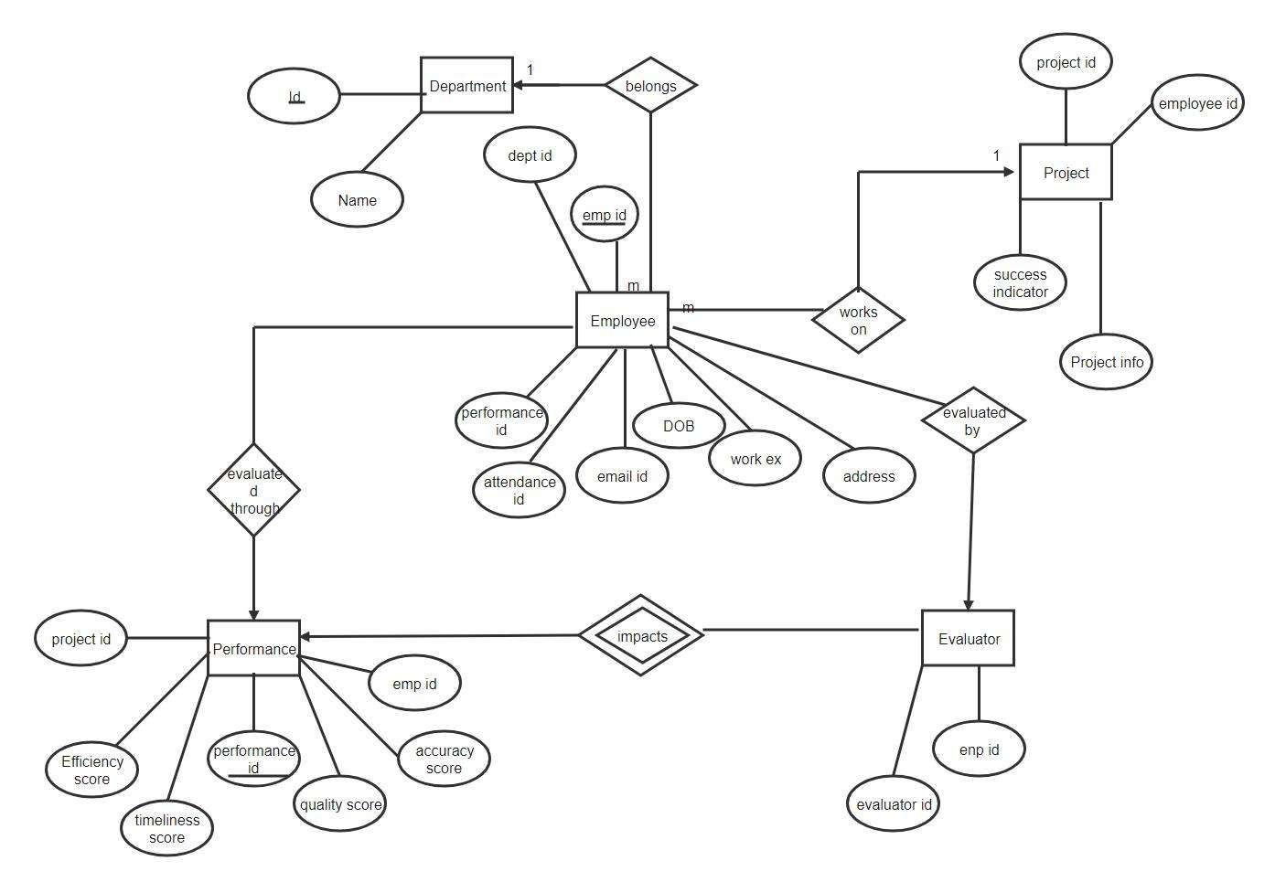

6.Basic Parts of an ER Diagram
- Entity (Rectangle) → Example: User, Goal, Task
- Attribute (Oval) → Example: Name, ID, Date
- Relationship (Diamond) → Example: Creates, Completes, Has
- Lines → Connect entities with attributes and relationships.
Simple Example (Micro-Goal App ER Concept)
If you are making a micro-goal tracking system, the ER diagram could include:
Entities
- User (UserID, Name, Email)
- Goal (GoalID, Title, TargetDate)
- Task (TaskID, Description, Status)
Relationships
- User creates Goal
- Goal contains Tasks
- User completes Tasks

